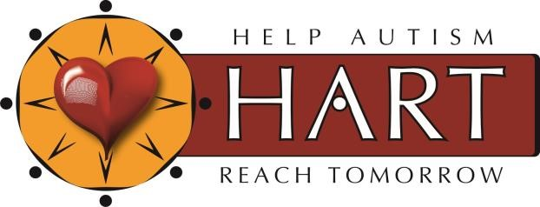
Autism Diagnostic Observation Schedule, Second Edition (ADOS-2)
Autism Diagnostic Observation Schedule, 2nd Edition (ADOS-2) 2020 Clinical Training Workshop

This training is for professionals interested in becoming a certified ADOS-2 examiner. Registration will be closed at 30 people. Payment must be paid in full prior to July 1, 2022 Attending ALL three days will allow you to assess people of all ages from 18 months through adulthood. After July 1, 2022 those wanting the Toddler Module only will be contacted regarding availability. The fee for the Toddler Module is $299 while the $749 covers ALL three days that includes the Toddler Module. Please complete the attached registration form and submit via email to Dr. Kerri Duncan, BCBA,
Hart4autism2017@gmail.com. Details on payment information is located on the registration form.

ADOS-2 Clinical Training (Modules 1-4) and Toddler Module
July 25-27 2022
Fee: $749
This 3-day Clinical training covers all modules of the ADOS-2 and will include lectures, videos, demonstrations of administration and scoring, and discussions. One live evaluation will be conducted each day for coding purposes. This training is designed for researchers and clinicians with prior background in autism spectrum disorders and formal testing such as BCBA’s, speech- language pathologists, physicians, psychologists, and occupational therapists. This workshop serves as a pre-requisite for more thorough training required to obtain research reliability needed to use the ADOS-2 for research purposes. Attending this training will meet the requirements needed to administer the ADOS-2.

Prior to attending training, you will need to have access to an ADOS-2 manual. Please bring an ADOS-2 Manual with you to the three-day event. Each attendee will receive a copy of each protocol during the training to be used during a live assessment demonstration presented each day. ADOS-2 kits, manuals and protocols are available through Western Psychological Services at 1-800-648-8857 or at www.wpspublish.com.

OUR INSTRUCTOR

Dr. Norm Geller has been helping children, adults, and families through assessments, evaluation, and educational program planning for over 35 years. He received his Ph.D from Virginia Commonwealth University and his Master's Degree from Vanderbilt University. He specializes in learning disabilities, ADHD, autism, and psycho-educational assessment. In addition to assessment, Dr. Geller is an independent international trainer who provides professional development workshops on the ADOS-2. Dr. Geller holds appointments at both Virginia Commonwealth University in the School of
Education and the University of Richmond T.C. Williams School of Law. He has worked on specialized assessment teams at the Virginia Treatment Center for Children specializing in ADHD, mood disorders, and autism.

LOCATION: VIRTUAL
DATES: July 25, 26, & 27 2022

For questions: Contact Dr. Kerri Duncan 417-860-7640 hart4autism2017@gmail.com

ADOS-2 CLINICAL TRAINING: REGISTRATION AND
PAYMENT FORM

PLEASE TELL US ABOUT YOURSELF:

NAME: |  | DAY PHONE
DEGREE/TITLE: |  | FAX:
CURRENT  INSTITUTION: |  | ADDRESS:
PROFESSION: |  | CITY, STATE, ZIP:
EMAIL: |  | COUNTRY:

TIME: All trainings will begin at 8:30 am and end at 4:30 pm each day.

LOCATION: You will be sent a zoom link three days prior to the start of the training.

Payment And Refund Policy: We accept Venmo, Zelle, Check or money order. A course refund minus the $50.00 application fee will be sent to those who cancel at least 14 days prior to the course start date. The fee noted for each course includes a $50.00 non-refundable application fee and course materials

Requirements: It is recommended that you bring an ADOS-2 manual to the training. ADOS-2 protocols will be available and you are not required to bring them. Participants in the Toddler Training must have attended Clinical Training Modules 1-4.

PAYMENT INFORMATION

 |  | Date | Training | FEE
 |  | July 25-27 | Clinical ADOS-2 Training for Modules 1-4 and Toddler Module (3 days total) | $749
 |  | July 27, 2022 | Toddler Module Only (must have Modules 1-4 training prior to taking this one day only course) | $299

**PLEASE PAY ONLINE USING PAYPAL ON THE HART4AUTISM.COM WEBSITE**
Make checks payable to Kerri Duncan, LLC

REGISTRATION DEADLINE: July 1, 2022

To submit your registration form by email:
Hart4autism2017@gmail.com
To submit your registration and check by mail:
Dr. Kerri Duncan 8591 Lakeside Dr. Englewood, FL 34224

IF YOU HAVE QUESTIONS, CONTACT DR. KERRI 417-8607640
www.hart4autism.com
hart4autism2017@gmail.com

